SEARCHING FOR THE SWEET LIFE:
ARCHAEOLOGY AT THE CHATSWORTH PLANTATION SITE

Dennis Jones
Louisiana State University Rural Life Museum

The Louisiana State University Rural Life Museum (RLM) was very grateful to receive the 2014 Public Outreach Grant from the Southeastern Archaeological Conference. The grant partially funded the production of a documentary video about an archaeological project at the Chatsworth Plantation site (16EBR192) in East Baton Rouge Parish, Louisiana. The archaeological project was performed as part of Section 106 compliance by the Pinnacle Entertainment Corporation (PNK), which built a hotel/casino over the existing Mississippi River levee. This construction required a permit from the U.S. Army Corps of Engineers, which in turn triggered the cultural resources management project.

The hotel/casino is on a portion of what was once a 1000+ acre ante- and post-bellum sugar cane operation called Chatsworth Plantation. This plantation was founded by Fergus Duplantier, the French Creole son of Armand Duplantier, the aide de camp for the Marquis de Lafayette, the commander of French forces during the American Revolution. In 1830, Fergus began consolidating several Spanish colonial era land grants to begin the enterprise of growing and processing sugar cane. This crop, still cultivated in Louisiana, was then a newly lucrative but risky enterprise that required the construction of a steam-powered sugar mill at Chatsworth Plantation. The plantation’s development also led to the eventual acquisition of over 150 enslaved African Americans, and the construction of 50-room showplace “Big House” that stood for almost 100 years. Bankrupt by 1928, the once thriving Chatsworth Plantation, minus the Chatsworth Mansion that was demolished in 1930, was largely overgrown and forgotten until this project.

With the award of the contract by PNK to the LSU Rural Life Museum in 2012 for the cultural resources investigations, archaeological fieldwork began in the fall of that year. The work focused on the Chatsworth Sugar Mill, an overgrown heap of 19th century industrial rubble, and at the remains of several cabins in the Chatsworth Quarters, where enslaved and wage laborers lived into the early 20th century. The information from this work was combined with data gathered earlier by Coastal Environments, Inc., a respected Baton Rouge-based cultural resources management firm. The artifacts, archaeology, and archival information about Chatsworth Plantation have come together to make this one of the most thoroughly archaeologically researched plantations in the South.

During the fieldwork at Chatsworth, television and newspaper reporters visited to inform their audiences know about the RLM project. The RLM also organized two “Archaeological Field Days” that showcased the project to the general public. Mr. Rob Kreiger, a reporter with the television station WBRZ in Baton Rouge, was one of the most enthusiastic media members to cover the project. Archaeologist Dennis Jones, the Principal Investigator, approached Rob about the possible production of a video that could tell the public about the history of the Chatsworth Plantation site and what archaeology adds to that history.
With the award of the SEAC Public Outreach grant in March 2014, Rob Kreiger obtained permission from WBRZ to use his news coverage video footage of the project. Kreiger shot additional video footage of project personnel at the RLM in the summer of 2014, as well as structures on the RLM grounds that are similar to the structures that had once existed on Chatsworth Plantation. He also shot footage of activities in the RLM’s archaeological lab facility and interviewed many of the project’s personnel. Kreiger and Jones had numerous conversations and email exchanges about the project and Rob provided the voice narration for the final product.

Searching for the Sweet Life is being distributed in multiple venues. Hundreds of visitors to the RLM have viewed the 15-minute video. It was posted on the Facebook pages for the RLM project and the Louisiana Archaeological Society (LAS), and there have been over 1500 hits on two Facebook postings thus far. The video was presented at the 2014 South Central Historical Archaeological Conference in Memphis and shown at the 2015 annual meeting of the LAS. It is available to view on YouTube (www.youtube.com/watch?v=AFyCOF5Z78k). The video is entered into the 2015 Film and Video Festival sponsored by The Archaeology Channel and will be available for viewing there (www.archaeologychannel.org).

A looping portion of the video is part of a travelling exhibit about the project. The first venue for that exhibit was recently completed at the Student Union at the University of Louisiana-Monroe as part of Louisiana Archaeology Month in October 2014. This exhibit is scheduled to travel to several libraries, museums, and campuses for 2015. This video segment will be seen by thousands of numerous people at the various venues.

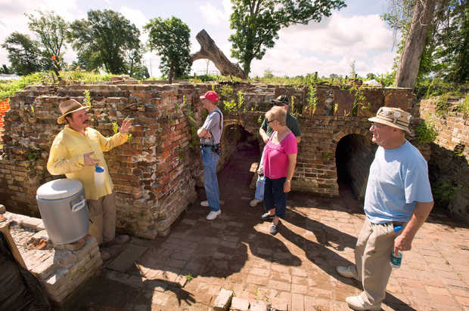
Left to right, Matt McGraw, a graduate research assistant at LSU's Rural Life Museum, explains the unearthed area of brick construction where an engine turned a flywheel and gears and rollers that extracted juice from sugar cane, to visitors John R. Smith, Drue Lewis and her husband George Lewis (partially obscured) and Ron Read, a member of the Louisiana Archeological Society, Saturday. They were at an archaeology field day, at the site of Chatsworth Plantation and its19th century sugar mill, on land next to L'Auberge Casino & Hotel Baton Rouge. (AP Photo/The Advocate, Travis Spradling)

